## **Objectives**

* Explain React State

**Definition:** State is a built-in object in React used to store dynamic data within a component.

**Purpose:** It allows components to create and manage internal data that can change over time.

**Mutability:** State is mutable (can be changed using setState or useState) unlike props which are read-only.

**Triggers:** When state changes, React automatically re-renders the component to reflect the new state.

**Scope:** State is local to the component in which it is declared.

**Usage:**

* In Class Components, use `this.state` to define state and `this.setState()` to update it.
* In Functional Components, use the `useState()` Hook.

**Example (Class Component):**

class Counter extends React.Component {

constructor(props) {

super(props);

this.state = { count: 0 };

}

increment = () => {

this.setState({ count: this.state.count + 1 });

}

render() {

return (

<div>

<p>Count: {this.state.count}</p>

<button onClick={this.increment}>Increment</button>

</div>

);

}

}

Key Differences Between Props and State:

|  |  |
| --- | --- |
| Feature | Description |
| Definition | Internal data storage for a component |
| Mutability | Mutable – can be changed using `setState()` (class) or `useState()` (hooks) |
| Scope | Local to the component |
| Trigger Re-render | Changing state triggers a UI update |
| Initialization | Set using constructor (class) or `useState()` (functional) |

## **Notes**

Estimated time to complete this lab: **60 minutes.**

Create a React App “counterapp” which will have a component named “CountPeople” which will have 2 methods.

UpdateEntry() 🡪 which will display the number of people who entered the mall.

UpdateExit() 🡪 which will display the number of people who exited the mall.

Use Constructor and state to Store the entrycount and exitcount.

The component has 2 buttons

1. Login 🡪 when clicked, the entrycount should get incremented by 1
2. Exit 🡪 when clicked, the exitcount should get incremented by 1

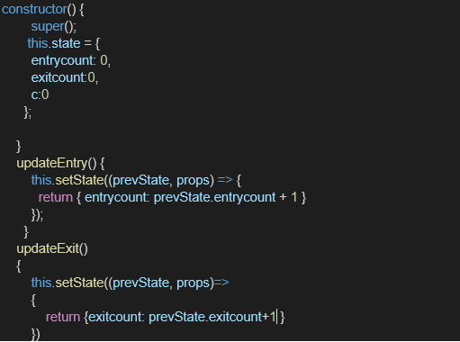

The output should be as follows:

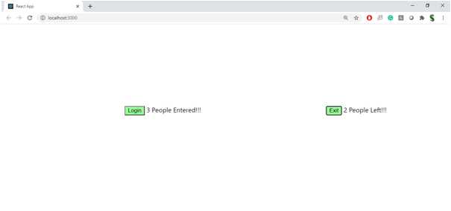

HandsOn:

